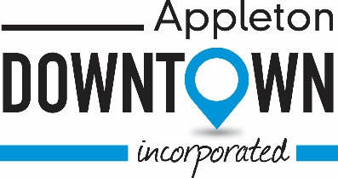
Panel Discussion Topic:

“Extending the reach of your Farmers Market
through promotion and relationships”

How important are promotion and business relationships to you? Are they necessary? A few questions to ask yourself if you are holding an event, in this case; farmers market, how are you going to fund it?

Farmers markets are an opportunity to promote a healthy lifestyle through a unique shopping environment. They offer fresh fruits and vegetables, locally produced products like honey and bakery, ethnic food, entertainment and local artisan crafted products. Markets offer farmers and artists the opportunity to sell their products; all while encouraging a long-term philosophy of shopping local.

Did you know that markets are an economic driver to improve business exposure, supplement revenue streams, as well as a recruitment tool for new businesses into a community? Many brick and mortar businesses were started by selling at smaller markets, including farmers markets.

During this discussion, you are going to learn from our panelists, how they promote personally, as well as for the market. You’re going to hear from various sized markets, as well as customers, on how they promote themselves and the benefits or downfalls of the farmers market as a “cross-promoter”. Additional topics that we hope to cover, will also include sponsorships…the who, why, when and whether they’re necessary for your market. A sneak peek insight from the experts.

As this is a panel discussion, the discussion might go in a variety of directions, and the list of questions I have typed up as a moderator; may or may not all get answered. That is what makes having panel discussions interesting. They go in a variety of directions and don’t have a set path.

Djuanna Hugdahl
Community Partnership Director
Downtown Appleton Farm Market
Appleton Downtown Inc.

